9. Sequence Diagram: Test Request & Specimen Collection

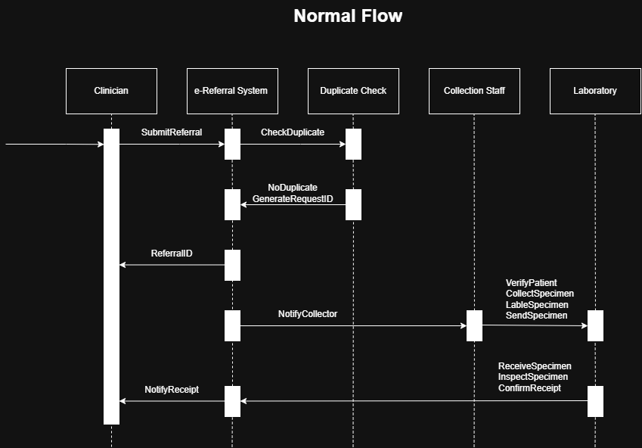
Figure 1. Sequence Diagram - Normal Flow

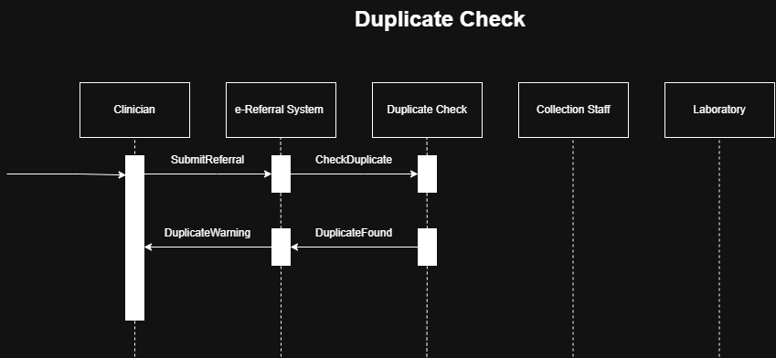
Figure 2. Sequence Diagram – Duplication

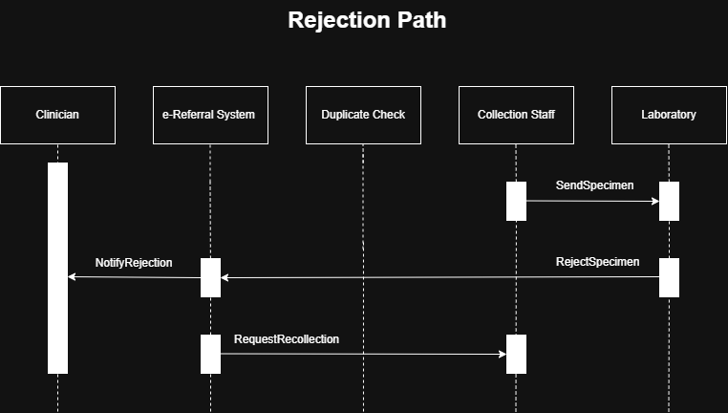
Figure 3. Sequence Diagram – Rejection Path

